**ANNEX I**

SUMMARY OF PRODUCT CHARACTERISTICS

BT_1000x858pxThis medicinal product is subject to additional monitoring. This will allow quick identification of new safety information. Healthcare professionals are asked to report any suspected adverse reactions. See section 4.8 for how to report adverse reactions.

**1. NAME OF THE MEDICINAL PRODUCT**

CRYSVITA 10 mg solution for injection

CRYSVITA 20 mg solution for injection

CRYSVITA 30 mg solution for injection

**2. QUALITATIVE AND QUANTITATIVE COMPOSITION**

CRYSVITA 10 mg solution for injection

Each vial contains 10 mg of burosumab in 1 ml solution.

CRYSVITA 20 mg solution for injection

Each vial contains 20 mg of burosumab in 1 ml solution.

CRYSVITA 30 mg solution for injection

Each vial contains 30 mg of burosumab in 1 ml solution.

Burosumab is a recombinant human monoclonal IgG1 antibody for FGF23 and is produced by recombinant DNA technology using Chinese hamster ovary (CHO) mammalian cell culture.

Excipient with known effect

Each vial contains 45.91 mg sorbitol.

For the full list of excipients, see section 6.1.

**3. PHARMACEUTICAL FORM**

Solution for injection (injection).

Clear to slightly opalescent, colourless to pale brownish-yellowish solution.

**4. CLINICAL PARTICULARS**

**4.1 Therapeutic indications**

CRYSVITA is indicated for the treatment of X-linked hypophosphataemia, in children and adolescents aged 1 to 17 years with radiographic evidence of bone disease, and in adults.

**4.2 Posology and method of administration**

Treatment should be initiated by a physician experienced in the management of patients with metabolic bone diseases.

Posology

Oral phosphate and active vitamin D analogues (e.g. calcitriol) should be discontinued 1 week prior to initiation of treatment. Vitamin D replacement or supplementation with inactive forms may be started or continued as per local guidelines under monitoring of serum calcium and phosphate. At initiation, fasting serum phosphate concentration should be below the reference range for age (see section 4.3).

***Dosing in Children and Adolescents aged 1 to 17 years***

The recommended starting dose in children and adolescents aged 1 to 17 years is 0.8 mg/kg of body weight given every two weeks. Doses should be rounded to the nearest 10 mg. The maximum dose is 90 mg.

After initiation of treatment with burosumab, fasting serum phosphate should be measured every 2 weeks for the first month of treatment, every 4 weeks for the following 2 months and thereafter as appropriate. Fasting serum phosphate should also be measured 4 weeks after any dose adjustment. If fasting serum phosphate is within the reference range for age, the same dose should be maintained.

*Dose increase*

If fasting serum phosphate is below the reference range for age, the dose may be increased stepwise by 0.4 mg/kg up to a maximum dose of 2.0 mg/kg (maximum dose of 90 mg). Fasting serum phosphate should be measured 4 weeks after dose adjustment. Burosumab should not be adjusted more frequently than every 4 weeks.

*Dose decrease*

If fasting serum phosphate is above the reference range for age, the next dose should be withheld and the fasting serum phosphate reassessed within 4 weeks. The patient must have fasting serum phosphate below the reference range for age to restart burosumab at half of the previous dose, rounding the amount as described above.

*Dose Conversion at age 18 years*

Children and adolescents aged 1 to 17 years should be treated using the dosing guidance outlined above. At 18 years of age the patient should convert to the adult dose and dosing regimen as outlined below.

***Dosing in Adults***

The recommended starting dose in adults is 1.0 mg/kg of body weight, rounded to the nearest 10 mg up to a maximum dose of 90 mg, given every 4 weeks.

After initiation of treatment with burosumab, fasting serum phosphate should be measured every 2 weeks for the first month of treatment, every 4 weeks for the following 2 months and thereafter as appropriate.  Fasting serum phosphate should be measured 2 weeks after the previous dose of burosumab. If serum phosphate is within the normal range, the same dose should be continued.

Dose decrease

If serum phosphate is above the upper limit of normal range, the next dose should be withheld and the serum phosphate level reassessed within 2 weeks. The patient must have serum phosphate below the normal range before restarting burosumab. Once serum phosphate is below the normal range, treatment may be restarted at half the initial starting dose up to a maximum dose of 40 mg every 4 weeks. Serum phosphate should be reassessed 2 weeks after any change in dose.

***All Patients***

To decrease the risk for ectopic mineralisation, it is recommended that fasting serum phosphate is targeted in the lower end of the normal reference range for age (see section 4.4).

*Missed dose*

Treatments may be administered 3 days either side of the scheduled treatment date if needed for practical reasons. If a patient misses a dose, burosumab should be resumed as soon as possible at the prescribed dose.

Special populations

*Renal impairment*

Burosumab has not been studied in patients with renal impairment. Burosumab must not be given topatients with severe or end stage renal disease (see section 4.3).

*Paediatric population*

The safety and efficacy of burosumab in children aged less than one year have not been established in clinical studies.

*Elderly*

Limited data is available in patients over 65 years of age.

Method of administration

For subcutaneous use.

Burosumab should be injected in the arm, abdomen, buttock or thigh.

The maximum volume of medicinal product per injection site is 1.5 ml. If more than 1.5 ml is required on a given dosing day, the total volume of medicinal product must be split and administered at two or more different injection sites. Injection sites should be rotated and carefully monitored for signs of potential reactions (see section 4.4).

For handling of burosumab before administration, see section 6.6.

**4.3 Contraindications**

Hypersensitivity to the active substance or to any of the excipients listed in section 6.1.

Concurrent administration with oral phosphate, active vitamin D analogues (see section 4.5).

Fasting serum phosphate above the normal range for age due to the risk of hyperphosphatemia (see section 4.4).

Patients with severe renal impairment or end stage renal disease.

**4.4 Special warnings and precautions for use**

Traceability

In order to improve the traceability of biological medicinal products, the name and the batch number

of the administered product should be clearly recorded within the patient’s records.

Ectopic mineralisation

Ectopic mineralisation, as manifested by nephrocalcinosis, has been observed in patients with XLH treated with oral phosphate and active vitamin D analogues; these medicinal products should be stopped at least 1 week prior to initiating burosumab treatment (see section 4.2).

Monitoring for signs and symptoms of nephrocalcinosis, e.g. by renal ultrasonography, is recommended at the start of treatment and every 6 months for the first 12 months of treatment, and annually thereafter. Monitoring of plasma alkaline phosphatase, calcium, parathyroid hormone (PTH) and creatinine is recommended every 6 months (every 3 months for children 1 - 2 years) or as indicated.

Monitoring of urine calcium and phosphate is suggested every 3 months.

Hyperphosphataemia

Levels of fasting serum phosphate should be monitored due to the risk of hyperphosphatemia. To decrease the risk for ectopic mineralisation, it is recommended that fasting serum phosphate is targeted in the lower end of the normal reference range for age. Dose interruption and/or dose reduction may be required (see section 4.2). Periodic measurement of post prandial serum phosphate is advised.

Serum parathyroid hormone

Increases in serum parathyroid hormone have been observed in some XLH patients during treatment with burosumab. Periodic measurement of serum parathyroid hormone is advised.

Injection site reactions

Administration of burosumab may result in local injection site reactions. Administration should be interrupted in any patient experiencing severe injection site reactions (see section 4.8) and appropriate medical therapy administered.

Hypersensitivity

Burosumab must be discontinued if serious hypersensitivity reactions occur and appropriate medical treatment should be initiated.

Excipient with known effect

This medicine contains 45.91 mg of sorbitol in each vial which is equivalent to 45.91 mg/ml.

**4.5 Interaction with other medicinal products and other forms of interaction**

Concurrent administration of burosumab with oral phosphate and active vitamin D analogues is contraindicated as it may cause an increased risk of hyperphosphatemia and hypercalcaemia (see section 4.3).

Caution should be exercised when combining burosumab with calcimimetic medicinal products (i.e. agents that mimic the effect of calcium on tissues by activating the calcium receptor). Co‑administration of these medicinal products has not been studied in clinical trials and could potentially exacerbate hypocalcaemia.

**4.6 Fertility, pregnancy and lactation**

Pregnancy

There are no or limited amount of data from the use of burosumab in pregnant women.

Studies in animals have shown reproductive toxicity (see section 5.3).

Burosumab is not recommended during pregnancy and in women of childbearing potential not using contraception.

Breast-feeding

It is unknown whether burosumab/metabolites are excreted in human milk.

A risk to newborns/infants cannot be excluded.

A decision must be made whether to discontinue breast-feeding or to discontinue/abstain from burosumab therapy taking into account the benefit of breast feeding for the child and the benefit of therapy for the woman.

Fertility

Studies in animals have shown effects on male reproductive organs (see section 5.3). There are no clinical data available on the effect of burosumab on human fertility. No specific fertility studies in animals with burosumab were conducted.

**4.7 Effects on ability to drive and use machines**

Burosumab may have a minor influence on the ability to drive and use machines. Dizziness may occur following administration of burosumab.

**4.8 Undesirable effects**

Summary of the safety profile

The most common (>10%) adverse drug reactions reported in paediatric patients treated for up to 64 weeks during clinical trials were: injection site reactions (56%), cough (56%), headache (50%), pyrexia (43%), pain in extremity (40%), vomiting (39%), tooth abscess (35%), vitamin D decreased (32%), diarrhoea (25%), rash (24%), nausea (15%), constipation (11%), dental caries (11%) and myalgia (11%).

The most common adverse drug reactions reported in adult patients during clinical trials were: back pain (23%), headache (21%), tooth infection (19%), restless legs syndrome (13%), muscle spasms (12%), vitamin D decrease (15%) and dizziness (11%).

(See section 4.4 and ‘Description of selected adverse reactions’ below).

Tabulated list of adverse reactions

The adverse reactions are presented by system organ class and frequency categories, defined using the following convention: very common (≥1/10); common (≥1/100 to <1/10); uncommon (≥1/1000 to <1/100); rare (≥1/10,000 to <1/1000); very rare (<1/10,000), not known (cannot be estimated from the available data). Within each frequency grouping, undesirable effects are presented in order of decreasing seriousness.

An overview of adverse reactions observed from clinical trials in paediatric patients is presented in Table 1.

Table 1: Adverse reactions reported in paediatric patients with XLH based on clinical studies UX023-CL201, UX023-CL205 and UX023-CL301 (N=94)

|  |  |  |
| --- | --- | --- |
| **MedDRA System Organ Class** | **Frequency category** | **Adverse reaction** |
| Infections and infestations | Very common | Tooth abscess1 |
| Respiratory, thoracic and mediastinal disorders | Very common | Cough2 |
| Nervous system disorders | Very common | Headache |
| Common | Dizziness3 |
| Gastrointestinal Disorders | Very common | Vomiting  Nausea  Diarrhoea  Constipation  Dental Caries |
| Skin and subcutaneous tissue disorders | Very common | Rash4 |
| Musculoskeletal and connective tissue disorders | Very common | Myalgia |
| Pain in extremity |
| General disorders and administration site conditions | Very common | Injection site reaction5  Pyrexia |
| Investigations | Very common | Vitamin D decreased6 |

1Tooth abscess includes: *Tooth abscess, Tooth infection and Toothache*

2Cough includes: *Cough, and Productive cough*

3Dizziness includes: *Dizziness, and Dizziness exertional*

4Rash includes: *Rash, Rash erythematous, Rash generalised, Rash pruritic, Rash maculo-papular, and Rash pustular*

5Injection site reaction includes: *Injection site reaction, Injection site erythema, Injection site pruritus, Injection site swelling, Injection site pain, Injection site rash, Injection site bruising, Injection site discolouration, Injection site discomfort, Injection site haematoma, Injection site haemorrhage, Injection site induration, Injection site macule, and Injection site urticaria*

6Vitamin D decreased includes: *Vitamin D deficiency, Blood 25-hydroxycholecalciferol decreased, and Vitamin D decreased*

An overview of adverse reactions observed from clinical trials in adults is presented in Table 2.

Table 2: Adverse reactions reported in adults with XLH (N=176)

|  |  |  |
| --- | --- | --- |
| **MedDRA System Organ Class** | **Frequency Category** | **Adverse Reaction** |
| Infections and infestations | Very common | Tooth infection1 |
| Nervous system disorders | Very common | Headache2 |
| Very common | Dizziness |
| Very common | Restless legs syndrome |
| Gastrointestinal disorders | Common | Constipation |
| Musculoskeletal and connective tissue disorders | Very common | Back pain |
| Very Common | Muscle spasms |
| Investigations | Very common | Vitamin D decreased3 |
| Common | Blood phosphorus increased4 |

1 Tooth infection includes: *tooth abscess and tooth infection*

2 Headache includes*: headache and head discomfort*

3Vitamin D decreased includes: *Vitamin D deficiency, Blood 25-hydroxycholecalciferol decreased, and Vitamin D decreased*

4Blood phosphorus increased includes: *blood phosphorus increased, and hyperphosphataemia*

Description of selected adverse reactions

*Injection site reactions*

*Paediatric patients:*

Local reactions (e.g. injection site urticaria, erythema, rash, swelling, bruising, pain, pruritus, and haematoma) have occurred at the site of injection. In the paediatric studies, approximately 56% of the patients had an injection site reaction. The injection site reactions were generally mild in severity, occurred within 1 day of medicinal product administration, lasted approximately 1 to 3 days, required no treatment, and resolved in almost all instances.

*Adult patients:*

The frequency of injection site reactions was 12% in both burosumab and placebo treatment groups (injection site reaction, erythema, rash, bruising, pain, pruritis and haematoma). The injection site reactions were generally mild in severity, occurred within 1 day of medicinal product injection, lasted approximately 1 to 3 days, required no treatment, and resolved in almost all instances.

*Hypersensitivity*

*Paediatric patients:*

Hypersensitivity reactions (including:injection site rash, rash, urticaria, swelling face, dermatitis) were reported in 18% of paediatric patients. All reported reactions were mild or moderate in severity.

*Adult patients:*

The incidence of potential hypersensitivity reactions was similar (6%) in the burosumab treated and placebo treated adults. The events were mild to moderate in severity.

*Vitamin D Decreased*

*Paediatric patients:*

Reduced serum 25 hydroxy-vitamin D has been observed following initiation of burosumab treatment in approximately 8% of paediatric patients, possibly due to increased conversion to activated 1,25 dihydroxy-vitamin D. Supplementation with inactive vitamin D was successful in restoring plasma levels to normal.

*Hyperphosphataemia*

*Adult patients:*

In the double-blind period of Study UX023-CL303, in the burosumab group during the

Placebo-controlled Treatment Period, 9 subjects (13.2%) had high serum phosphate at least

once; 5 of these 9 required protocol-specified dose reduction(s). After initiation of burosumab in the open-label Treatment Continuation Period, 8 subjects (12.1%) in the placebo→burosumab group had high serum phosphate levels. Four of these 8 subjects required protocol-specified dose reduction(s). The dose for all patients meeting the protocol-specified criteria was reduced by 50%. A single patient (1%) required a second dose reduction for continued hyperphosphataemia.

*Restless legs syndrome*

*Adult patients:*

In adults, approximately 12% of the burosumab treatment group and 8% in the placebo group had a worsening of baseline restless legs syndrome or new onset restless legs syndrome of mild to moderate severity.

*Immunogenicity:*

*Paediatric and adult patients*

Overall, the incidence of anti-drug antibodies (ADA) to burosumab was <10% in adults and paediatric subjects administered burosumab. The incidence of neutralising ADA was 3.2% and neutralising ADA were only found in paediatric subjects. No adverse events, loss of efficacy, or changes in pharmacokinetics profile were associated with these findings.

Reporting of suspected adverse reactions

Reporting suspected adverse reactions after authorisation of the medicinal product is important. It allows continued monitoring of the benefit/risk balance of the medicinal product. Healthcare professionals are asked to report any suspected adverse reactions via the national reporting system listed in [Appendix V](http://www.ema.europa.eu/docs/en_GB/document_library/Template_or_form/2013/03/WC500139752.doc).

**4.9 Overdose**

There is no experience with overdose of burosumab. Burosumab has been administered in paediatric clinical trials without dose limiting toxicity using doses up to 2.0 mg/kg body weight with a maximal dose of 90 mg every two weeks. In adult clinical trials no dose limiting toxicity has been observed using doses up to 1.0 mg/kg or a maximal total dose of 128 mg every 4 weeks.

Management

In case of overdose, it is recommended to stop burosumab and to monitor biochemical response.

**5. PHARMACOLOGICAL PROPERTIES**

**5.1 Pharmacodynamic properties**

Pharmacotherapeutic group: Drugs for the treatment of bone diseases, other drugs affecting bone structure and mineralisation, ATC code: M05BX05.

Mechanism of action

Burosumab is a recombinant human monoclonal antibody (IgG1) that binds to and inhibits the activity of fibroblast growth factor 23 (FGF23). By inhibiting FGF23, burosumab increases tubular reabsorption of phosphate from the kidney and increases serum concentration of 1,25 dihydroxy‑Vitamin D.

Clinical efficacy in paediatric patients with XLH

*Study UX023-CL301*

In paediatric study UX023-CL301 61 patients aged 1 to 12 years (56% female; 44% male, Age at first dose, mean (SD): 6.3 (3.31) years) were randomised to burosumab (n=29) or active control (n=32; oral phosphate and active vitamin D). At entry to the study all patients had to have had a minimum of 6 months treatment of oral phosphate and active vitamin D. All patients had radiographic evidence of bone disease due to XLH (Rickets severity score ≥2). Burosumab was started at a dose of 0.8 mg/kg every 2 weeks and increased to 1.2 mg/kg if there was inadequate response, as measured by fasting serum phosphate. Those patients randomised to active control group received multiple daily doses of oral phosphate and active vitamin D.

The primary efficacy endpoint was the change in severity of rickets at Week 40, as assessed by the RGI-C (Radiographic Global Impression of change) score, compared between the burosumab and active control groups.

The RGI-C is a relative rating scale that compares a patient’s rickets before and after treatment utilising a 7-point ordinal scale to evaluate change in the same abnormalities rated in the RSS (as described below). Scores range from -3 (indicating severe worsening of rickets) to +3 (indicating complete healing of rickets).

The severity of paediatric rickets was measured using the RSS, a radiographic scoring method based on the degree of metaphyseal fraying, concavity, and the proportion of the growth plate affected. In the UX023-CL301 study, the RSS was scored using a predefined scale looking at specific abnormalities in the wrists and knees.

All patients completed at least 64 weeks of randomised treatment, no patients had dose reductions and 8 (28%) of burosumab-treated patients received dose escalations to 1.2 mg/kg.

Primary Efficacy Results

Greater healing of rickets at Week 40 was seen with burosumab treatment compared to active control and this effect was maintained at week 64, as shown in Figure 1.

Figure 1: RGI-C Global Score (Mean ± SE) – Primary Efficacy Endpoint at Week 40 and 64 (Full Analysis Set)

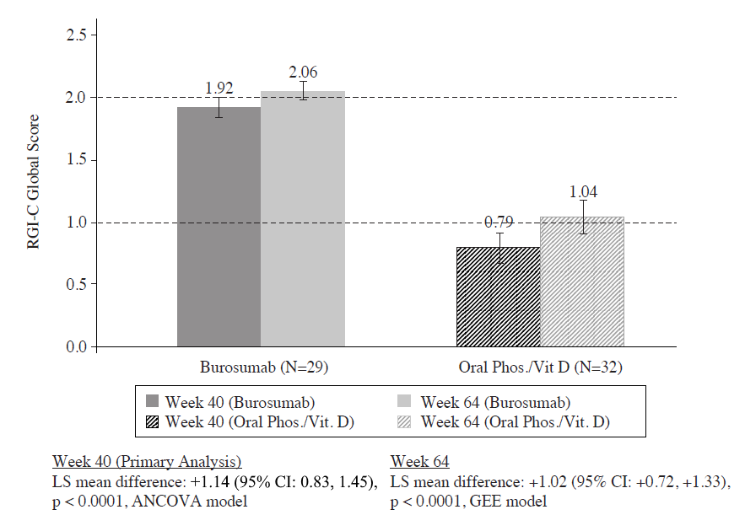

Secondary Efficacy Results

Key Secondary efficacy endpoint results are presented in Table 3.

**Table 3: Secondary Efficacy Endpoint Results**

|  |  |  |  |  |
| --- | --- | --- | --- | --- |
| **Endpoint** | **Week** | **Active Control**  LS Mean (SE) | **Burosumab**  LS Mean (SE) | **Difference** (burosumab – active control) |
| Lower Limb Deformity; assessed by RGI-C  (GEE model) | 40 | +0.22 (0.080) | +0.62 (0.153) | +0.40 [95% CI: 0.07, 0.72]  p = 0.0162 |
| 64 | +0.29 (0.119) | +1.25 (0.170) | +0.97 [95% CI: +0.57, +1.37]  p <0.0001 |
| Height; Z-score | Baseline | -2.05 (0.87) | -2.32 (1.17) |  |
| 40 a | +0.03 (0.031) | +0.16 (0.052) | +0.12 [95% CI: 0.01, 0.24]  p = 0.0408 |
| 64 b | +0.02 (0.035) | +0.17 (0.066) | +0.14 [95% CI: 0.00, 0.29]  p = 0.0490 |
| Rickets severity, RSS total Score | Baseline | 3.19 (1.141) | 3.17 (0.975) |  |
| 40 a | -0.72 (0.162) | -2.08 (0.104) | -1.34 [95% CI:  1.74, -0.94] p < 0.0001 |
| 64 b | -1.01 (0.151) | -2.23 (0.117) | -1.21 [95% CI:  -1.59, -0.83] p < 0.0001 |
| Serum ALP (U/L) | Baseline | 523 (154) | 511 (125) |  |
| 40 a | 489 (189) | 381 (99) | -97 [95% CI:  -138, -56] p < 0.0001 |
| 64 b | 495 (182) | 337 (86) | -147 [95% CI:  -192, -102] p < 0.0001 |
| Six Minute Walk Test (m) | Baseline | 450 (106) | 385 (86) |  |
| 40 a | +4 (14) | +47 (16) | +43 [95% CI:  -0.3, 87]  p = 0.0514 |
| 64 b | +29 (17) | +75 (13) | +46 [95% CI:  2, 89]  p = 0.0399 |

a: the change from Baseline to Week 40 from ANCOVA model.

b: the change from Baseline to Week 64 from GEE Model.

*Serum Phosphate*

At each study visit at which serum phosphate was assessed in both groups, changes in serum phosphate from Baseline were larger in the burosumab group compared with the active control group (p < 0.0001; GEE model) (Figure 2).

Figure 2: Serum Phosphate Concentration and Change from Baseline (mg/dL) (Mean ± SE) by Treatment Group (PD Analysis Set)

*Note: Dashed line in figure indicates the lower limit of the serum phosphate reference range, 3.2 mg/dL (1.03 mmol/L)*

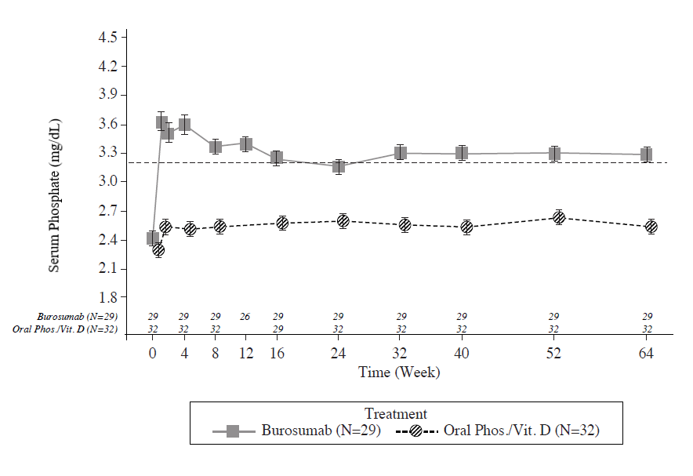

*Study UX023-CL201*

In paediatric Study UX023-CL201, 52 paediatric patients aged 5 to 12 years (mean 8.5 years; SD 1.87) with XLH were treated for 64 weeks. Nearly all patients had radiographic evidence of rickets at baseline and had received prior oral phosphate and vitamin D analogues for a mean (SD) duration of 7 (2.4) years. This conventional therapy was discontinued 2-4 weeks prior to burosumab initiation. The burosumab dose was adjusted to target a fasting serum phosphate concentration of 3.50 to 5.02 mg/dL (1.13 to 1.62 mmol/L). Twenty six of 52 patients received burosumab every 4 weeks (Q4W). Twenty six of 52 patients received burosumab every two weeks (Q2W) at an average dose (min, max) of 0.73 (0.3, 1.5), 0.98 (0.4, 2.0) and 1.04 (0.4, 2.0) mg/kg at weeks 16, 40 and 60 respectively, and up to a maximum dose of 2.0 mg/kg.

Burosumab increased serum phosphate concentration and increased TmP/GFR. In the group that received burosumab every 2 weeks, mean (SD) serum phosphate concentration increased from 2.38 (0.405) mg/dL (0.77 (0.131) mmol/L) at baseline), to 3.3 (0.396) mg/dL (1.07 (0.128) mmol/L) at Week 40 and was maintained to Week 64 at 3.35 (0.445) mg/dL (1.08 (0.144) mmol/L).

*Alkaline phosphatase activity*

Mean (SD) serum total alkaline phosphatase activity was 459 (105) U/L at baseline and decreased to 369 (76) U/L at Week 64 (-19.6%, p < 0.0001).

Bone-derived serum alkaline phosphatase content was 165 (52) μg/L [mean (SD)] at Baseline and 115 (31) μg/L at Week 64 (mean change: -28.5%).

The severity of paediatric rickets in Study UX023-CL201 was measured using the RSS, as described above. In Study UX023-CL201, the RSS was scored using a predefined scale looking at specific abnormalities in the wrists and knees. As a complement to the RSS assessment, the RGI-C rating scale was used. Results are summarised in Table 4.

Table 4: Rickets Response in Children 5-12 Years Receiving Burosumab in Study UX023-CL201

|  |  |  |  |
| --- | --- | --- | --- |
| **Endpoint** | **Duration of Burosumab**  **(week)** | **Effect Size** | |
| **Q2W (N=26)** | **Q4W (N=26)** |
| **RSS Total Score**  Baseline Mean (SD)  LS Mean change (SE) from baseline in total scorea (reduced RSS score indicates improvement in rickets severity) |  |  |  |
| 40 | 1.92 (1.2)  -1.06 (0.1) (p<0.0001) | 1.67 (1.0)  -0.73 (0.1) (p<0.0001) |
| 64 | -1.00 (0.1) (p<0.0001) | -0.84 (0.1) (p<0.0001) |
| **RGI-C Global Score**  LS Mean score (SE)a (positive indicates healing) | 40  64 | +1.66 (0.1) (p<0.0001)  +1.56 (0.1) (p<0.0001) | +1.47 (0.1) (p<0.0001)  +1.58 (0.1) (p<0.0001) |

1. The estimates of LS means and p-values are from the generalized estimation equation model accounting for baseline RSS, visits and regimen and its interaction.

Study UX023-CL205

In paediatric Study UX023-CL205, burosumab was evaluated in 13 XLH patients, aged 1 to 4 years (mean 2.9 years; SD 1.1) for 40 weeks. All patients had radiographic evidence of rickets at baseline and twelve patients had received oral phosphate and vitamin D analogues for a mean (SD) duration of 16.7 (14.4) months. This conventional therapy was discontinued 2-6 weeks prior burosumab initiation. Patients received burosumab at a dose of 0.8 mg/kg every two weeks.

In Study UX023-CL205, mean (SD) fasting serum phosphate concentration increased from 2.51 (0.284) mg/dL (0.81 (0.092) mmol/L) at baseline to 3.47 (0.485) mg/dL (1.12 (0.158) mmol/L) at Week 40.

*Serum alkaline phosphatase activity*

Mean (SD) serum total alkaline phosphatase activity was 549 (193.8) U/L at baseline and decreased to 335 (87.6) U/L at Week 40 (mean change: -36.3%).

*Rickets Severity Score (RSS)*

After 40 weeks of treatment with burosumab, mean total RSS improved from 2.92 (1.367) at baseline to 1.19 (0.522), corresponding to a change from baseline in LS mean (SE) change of -1.73 (0.132) (p<0.0001).

*Radiographic Global Impression of Change (RGI-C)*

After 40 weeks of treatment with burosumab, the LS mean (SE) RGI-C Global score was +2.33 (0.08) in all 13 patients (p < 0.0001) demonstrating healing of rickets. All 13 patients were considered RGI-C responders as defined by RGI-C global score ≥ +2.0.

The European Medicines Agency has deferred the obligation to submit the results of studies with burosumab in one or more subsets of the paediatric population in treatment of X-linked hypophosphataemia. See 4.2 for information on paediatric use.

This medicinal product has been authorised under a so-called ‘conditional approval’ scheme. This means that further evidence on this medicinal product is awaited.

The European Medicines Agency will review new information on this medicinal product at least every year and this SmPC will be updated as necessary.

Clinical efficacy in adults with XLH

*Study UX023-CL303*

Study UX023-CL303 is a randomised, double-blind, placebo-controlled study in 134 adult XLH patients. The study comprised of a 24-week placebo-controlled treatment phase followed by a 24-week open-label period where all patients received burosumab. Oral phosphate and active vitamin D analogues were not allowed during the study. Burosumab was administered at a dose of 1 mg/kg every 4 weeks. The primary endpoint of this study was normalisation of serum phosphate across the 24-week double-blind period. Key secondary endpoints included worst pain as measured by the Brief Pain Inventory (BPI) scale and stiffness and physical function as measured by the WOMAC (Western Ontario and McMaster Universities Osteoarthritis)Index. Exploratory endpoints included fracture and pseudofracture healing, enthesopathy, 6 Minute Walk Test, BPI Pain interference, Brief Fatigue Inventory (BFI) worst fatigue and BFI global fatigue score.

At study entry, the mean age of patients was 40 years (range 19 to 66 years) and 35% were male. 66 patients were randomised to placebo treatment and 68 to burosumab treatment; at baseline, mean (SD) serum phosphate was 0.62 (0.10) mmol/l [1.92 (0.32) mg/dL] and 0.66 (0.1 mmol/l) [2.03 (0.30) mg/dL] in the placebo and burosumab groups respectively.

For the primary efficacy endpoint, a greater proportion of patients treated with burosumab achieved a mean serum phosphate level above the lower limit of normal (LLN) compared to the placebo group through week 24 (Table 5 and Figure 3).

**Table 5: Proportion of Adult Patients Achieving Mean Serum Phosphate Levels Above the LLN at the Midpoint of the Dose Interval in Study UX023-CL303 (Double-Blind Period)**

|  | **Placebo** **(N = 66)** | **Burosumab  (N = 68)** |
| --- | --- | --- |
| Achieved Mean Serum Phosphate > LLN Across Midpoints of Dose Intervals Through Week 24 - n (%) | 7.6% (5/66) | 94.1% (64/68) |
| 95% CI | (3.3, 16.5) | (85.8, 97.7) |
| p-valuea |  | < 0.0001 |

The 95% CIs are calculated using the Wilson score method.

a P-value is from Cochran-Mantel-Haenszel (CMH) testing for association between achieving the primary endpoint and treatment group, adjusting for randomisation stratifications.

**Figure 3:** **Mean (± SE) Serum Phosphate Peak Concentrations (mg/dL** [**mmol/L**]**)**

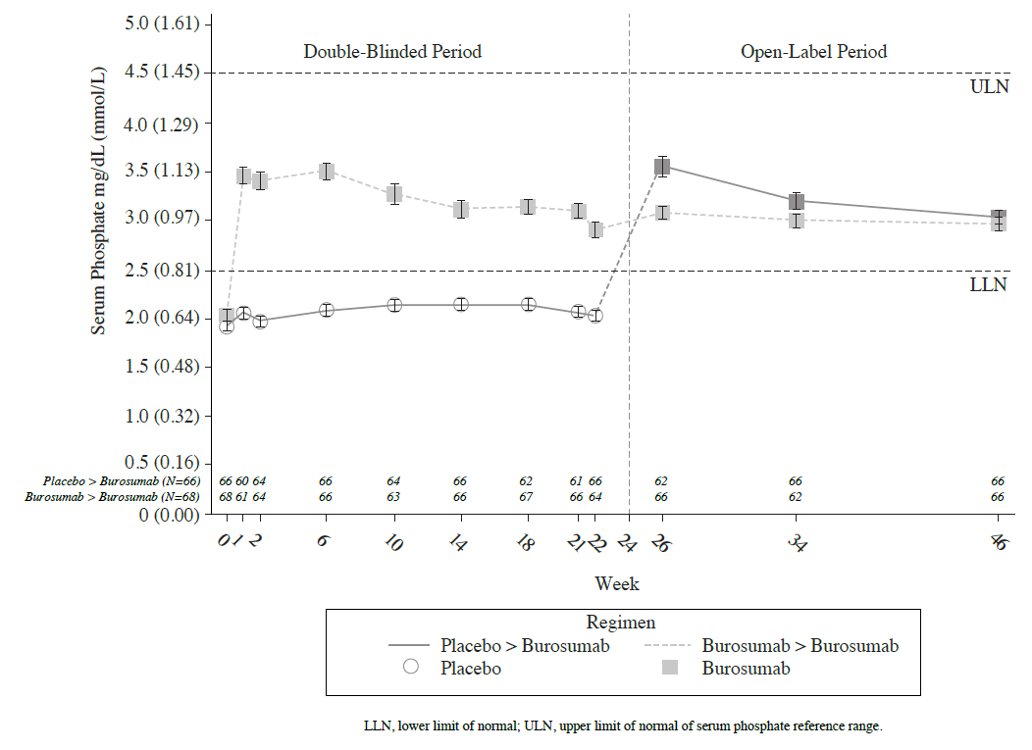

*Patient reported pain, physical function and stiffness*

Change from baseline at Week 24 showed a larger difference for burosumab relative to placebo in patient reported pain (BPI), physical function (WOMAC Index) and stiffness (WOMAC Index). The mean (SE) difference between treatment groups (burosumab-placebo) reach statistical significance for WOMAC stiffness at Week 24. Details are shown in Table 6.

**Table 6: Patient reported pain, physical function and stiffness score changes from baseline to Week 24 and analysis of difference at Week 24**

|  |  |  |  |  |
| --- | --- | --- | --- | --- |
|  | **Placebo** | | **Burosumab** | |
|  | N=66 | | N=68 | |
| ***BPI worst pain***a |  | |  | |
| LS Mean (SE) change from Baseline | -0.32 (0.2) | | -0.79 (0.2) | |
| [95% CIs] | [-0.76, 0.11] | | [-1.20, -0.37] | |
| LS Mean (SE) Difference (Burosumab-Placebo) | -0.5 (0.28) | | | |
| p-value | 0.0919c | | | |
| ***WOMAC Index physical function***b | | | | |
| LS Mean (SE) change from Baseline  [95% CIs] | | +1.79 (2.7)  [-3.54, 7.13] | | -3.11 (2.6)  [-8.12, 1.89] |
| LS Mean (SE) Difference | | -4.9 (2.5) | | |
| p-value | | 0.0478c | | |
| ***WOMAC Index stiffness***b | | | | |
| LS Mean (SE) change from Baseline  [95% CIs] | | +0.25 (3.1)  [5.89, 6.39] | | -7.87 (3.0)  [-13.82, -1.91] |
| LS Mean (SE) Difference (Burosumab-Placebo) | | -8.12 (3.2) | | |
| p-value | | 0.0122 | | |
| a BPI worst pain item score ranges from 0 (no pain) to 10 (pain as bad as you can imagine)  b WOMAC Index physical function and stiffness domains range from 0 (best health) to 100 (worst health)  c Not significant following Hochberg adjustment | | | | |

*6 Minute Walk Test*

This exercise test was conducted in all patients at Baseline, Week 12, 24, 36 and 48 (LS mean difference in change from baseline, burosumab → placebo; Table 7). Improvements continued through to Week 48 where distance walked increased from 357 m at baseline to 393 m at Week 48. Patients who crossed over from placebo to burosumab achieved similar improvements after 24 weeks of treatment.

**Table 7: 6 Minute Walk distance (SD) Baseline and Week 24; Least Squares Mean Difference (SE)**

|  |  |  |
| --- | --- | --- |
| **6 MWT, m(SD)** | **Placebo** | **Burosumab** |
| Baseline | 367 (103) | 357 (109) |
| Week 24 | 369 (103) | 382 (108) |
| LS Mean difference burosumab-placebo (SE) | 20 (7.7) | |

*Radiographic Evaluation of Fractures and Pseudofractures*

In Study UX023-CL303, a skeletal survey was conducted at baseline to identify osteomalacia-related fractures and pseudofractures. There were 52% (70/134) of patients who had either active fractures (12%, 16/134) or active pseudofractures (47%, 63/134) at baseline. Following burosumab treatment more patients showed healing of fractures and pseudofractures compared to the placebo group (Figure 4). During the placebo-controlled treatment period up to week 24, a total of 6 new fractures or pseudofractures appeared in 68 patients receiving burosumab compared to 8 new abnormalities in 66 patients receiving placebo. Of the number of new fractures developed prior to week 48 most (10/18) were healed or partially healed at the end of the study.

**Figure 4: Percentage of Healed Active Fractures and Pseudofractures in Study UX023-CL303**

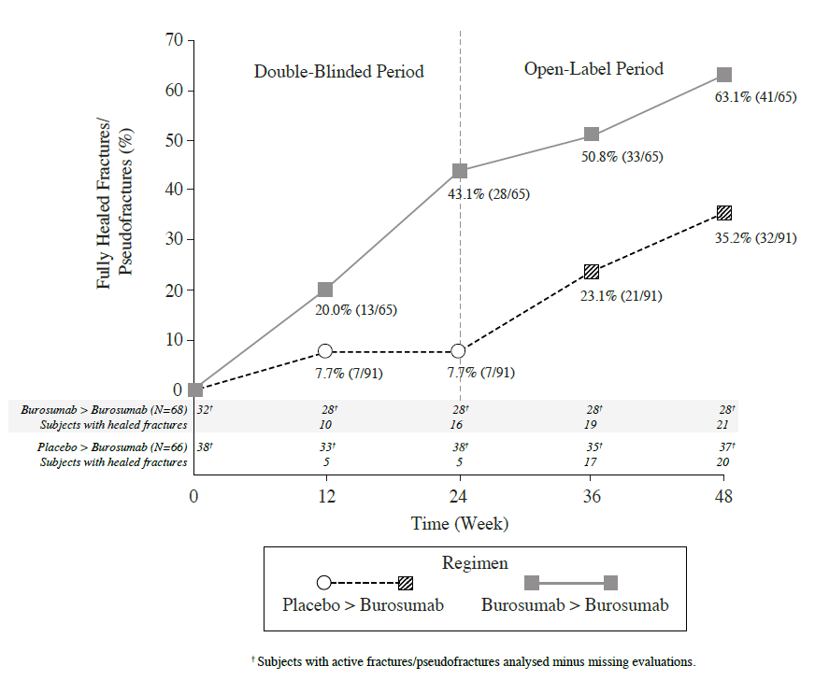

At Baseline, the mean (SD) total calcaneal enthesopathy burden (sum of superior and inferior calcaneal spurs) was 5.64 (3.12) cm in the burosumab group and 5.54 (3.1) cm in the placebo group. At Week 24, the mean (SD) total calcaneal enthesopathy burden was 5.90 (3.56) cm in the burosumab→burosumab group and 4.07 (2.38) cm in the placebo→burosumab group.

For the exploratory endpoints of BPI Pain interference, BFI worst fatigue and BFI global fatigue score no meaningful difference were observed between treatment arms.

*Bone Histomorphometry in Adults*

*Study UX023-CL304*

Study UX023-CL304 is a 48-week, open-label, single-arm study in adult XLH patients to assess the effects of burosumab on improvement of osteomalacia as determined by histologic and histomorphometric evaluation of iliac crest bone biopsies. Patients received 1.0 mg/kg burosumab every 4 weeks. Oral phosphate and active vitamin D analogues were not allowed during the study.

14 patients were enrolled, and at study entry, the mean age of patients was 40 years (range 25 to 52 years) and 43% were male. After 48 weeks of treatment in Study UX023-CL304 paired biopsies were available from 11 patients; healing of osteomalacia was observed in all ten evaluable patients as demonstrated by decreases in osteoid volume/bone volume (OV/BV) from a mean (SD) score of 26.1% (12.4) at baseline to 11.9% (6.6), Osteoid thickness (O.Th) declined in 11 evaluable patients from a mean (SD) of 17.2 (4.1) micrometres to 11.6 (3.1) micrometres.

**5.2 Pharmacokinetic properties**

Absorption

Burosumab absorption from subcutaneous injection sites to blood circulation is nearly complete. Following subcutaneous administration, the median time to reach maximum serum concentrations (Tmax) of burosumab is approximately 7-13 days. The peak serum concentration (Cmax) and area under the concentration-time curve (AUC) of serum burosumab is dose proportional over the dose range of 0.1‑2.0 mg/kg.

Distribution

In XLH patients, the observed volume of distribution of burosumab approximates the volume of plasma, suggesting limited extravascular distribution.

Biotransformation

Burosumab is composed solely of amino acids and carbohydrates as a native immunoglobulin and is unlikely to be eliminated via hepatic metabolic mechanisms. Its metabolism and elimination are expected to follow the immunoglobulin clearance pathways, resulting in degradation to small peptides and individual amino acids.

Elimination

Due to its molecular size, burosumab is not expected to be directly excreted. The clearance of burosumab is dependent on body weight and estimated to be 0.290 L/day and 0.136 L/day in a typical adult (70 kg) and paediatric (30 kg) XLH patient, respectively, with corresponding disposition half-life (t1/2) in the serum ranging from approximately 16 to 19 days. Given the t1/2 estimates, the estimated time to reach the plateau of steady-state exposures is approximately 67 days. Following multiple dose administration to paediatric subjects, observed serum trough concentrations reach a plateau by 8 weeks after initiation of treatment.

Linearity/non-linearity

Burosumab displays time-invariant pharmacokinetics that is linear to dose over the subcutaneous dose range of 0.1 to 2.0 mg/kg.

Pharmacokinetic/pharmacodynamic relationship(s)

With the subcutaneous route of administration, a direct PK-PD relationship between serum burosumab concentrations and increases in serum phosphate concentration is observed and well described by an Emax/EC50 model. Serum burosumab and phosphate concentrations, as well as TmP/GFR, increased and decreased in parallel and reached maximum levels at approximately the same time point after each dose, supporting a direct PK-PD relationship. The AUC for the change from baseline in serum phosphate, TmP/GFR and 1,25(OH)2D increased linearly with increasing burosumab AUC.

Paediatric PK/PD

No significant difference has been observed in paediatric patient pharmacokinetics or pharmacodynamics as compared with PK/PD in the adult population. Burosumab clearance and volume of distribution are body weight dependent.

Special Populations

Population PK analyses using data from paediatric and adult subjects who have XLH indicated that age, sex, race, ethnicity, baseline serum albumin, baseline serum alkaline phosphate, baseline serum alanine aminotransferase, and baseline creatinine clearance ≥ 49.9 mL/min, were not significant predictors of burosumab PK.

Post-Prandial Effect on Serum Phosphate and Calcium

The effect of burosumab on serum phosphate and calcium levels after food was investigated in two sub-studies (Study UX023-CL301 and UX023-CL303); 13 paediatric patients (aged >3 years) and 26 adult patients (aged 24-65 years). Serum phosphate and calcium were measured at the end of the treatment interval in paediatric patients and mid-interval in adults. Blood samples were taken after a period of fasting, and again 1-2 hours after a standardised meal.

Burosumab treatment did not cause post-prandial excursions above the age-adjusted upper limits of normal in serum phosphate or serum calcium in any paediatric or adult subject in the sub-studies.

**5.3 Preclinical safety data**

Adverse reactions in non-clinical studies with normal animals were observed at exposures which resulted in serum phosphate concentration greater than normal limits. These effects were consistent with an exaggerated response to the inhibition of normal FGF23 levels resulting in a supraphysiologic increase in serum phosphate beyond the upper limit of normal.

Studies in rabbits and adult and juvenile cynomolgus monkeys demonstrated dose-dependent elevations of serum phosphate and 1,25 (OH)2D confirming the pharmacologic actions of burosumab in these species. Ectopic mineralisation of multiple tissues and organs (e.g. kidney, heart, lung, and aorta), and associated secondary consequences (e.g. nephrocalcinosis) in some cases, due to hyperphosphataemia, was observed in normal animals at doses of burosumab that resulted in serum phosphate concentrations in animals greater than approximately 8 mg/dL (2.6 mmol/L). In a murine model of XLH, a significant reduction in the incidence of ectopic mineralisation was observed at equivalent levels of serum phosphate, suggesting that the risk of mineralisation is less in the presence of excess FGF23.

Bone effects seen in adult and juvenile monkeys included changes in bone metabolism markers, increases in thickness and density of cortical bone, increased density of total bone and thickening of long bone. These changes were a consequence of higher than normal serum phosphate levels, which accelerated bone turnover and also led to periosteal hyperostosis and a decrease in bone strength in adult animals, but not in juvenile animals at the doses tested. Burosumab did not promote abnormal bone development, as no changes in femur length or bone strength were noted in juvenile animals. Bone changes were consistent with the pharmacology of burosumab and the role of phosphate in bone mineralization, metabolism and turnover.

In repeat-dose toxicology studies of up to 40 weeks duration in cynomolgus monkeys, mineralisation of the rete testis/seminiferous tubules was observed in male monkeys; however, no changes were observed in semen analysis. No adverse effects on female reproductive organs were observed in these studies.

In the reproductive and developmental toxicology study performed in pregnant cynomolgus monkeys, moderate mineralisation of the placenta was seen in pregnant animals given 30 mg/kg of burosumab and occurred in animals with peak serum phosphate concentration greater than approximately 8 mg/dL (2.6 mmol/L). Shortening of the gestation period and associated increased incidence of premature births were observed in pregnant monkeys at doses of ≥ 0.3 mg/kg which corresponded to burosumab exposures that are ≥0.875- to 1.39-fold anticipated clinical levels. Burosumab was detected in serum from fetuses indicating that burosumab was transported across the placenta to the fetus. There was no evidence of teratogenic effects. Ectopic mineralisation was not observed in foetuses or offspring and burosumab did not affect pre- and postnatal growth including survivability of the offspring.

In preclinical studies, ectopic mineralisation has been observed in normal animals, most frequently in the kidney, given burosumab at doses that resulted in serum phosphate concentrations greater than 8 mg/dL (2.6 mmol/L). Neither new or clinically meaningful worsening of nephrocalcinosis nor ectopic mineralisation have been observed in clinical trials of patients with XLH treated with burosumab to achieve normal serum phosphate levels.

**6. PHARMACEUTICAL PARTICULARS**

**6.1 List of excipients**

L-histidine

D-sorbitol E420

Polysorbate 80

L-methionine

Hydrochloric acid, 10% (for pH adjustment)

Water for injections

**6.2 Incompatibilities**

In the absence of compatibility studies, this medicinal product must not be mixed with other medicinal products.

**6.3 Shelf life**

3 years.

**6.4 Special precautions for storage**

Store in a refrigerator (2°C to 8°C). Do not freeze.

Store in the original package in order to protect from light.

**6.5 Nature and contents of container**

Clear glass vial with butyl rubber stopper, and aluminium seal.

Pack size of one vial

**6.6 Special precautions for disposal and other handling**

Each vial is for single use only.

Do not shake the vial before use.

Burosumab should be administered using aseptic technique and sterile disposable syringes and injection needles.

Any unused medicinal product or waste material should be disposed of in accordance with local requirements.

**7. MARKETING AUTHORISATION HOLDER**

Kyowa Kirin Holdings B.V.

Bloemlaan 2

2132NP Hoofddorp

The Netherlands

+31 (0) 237200822

[medinfo@kyowakirin.com](mailto:medinfo@kyowakirin.com)

**8. MARKETING AUTHORISATION NUMBER(S)**

EU/1/17/1262/001

EU/1/17/1262/002

EU/1/17/1262/003

**9. DATE OF FIRST AUTHORISATION/RENEWAL OF THE AUTHORISATION**

Date of first authorisation: 19 February 2018

Date of latest renewal: 21 February 2020

**10. DATE OF REVISION OF THE TEXT**

Detailed information on this medicinal product is available on the website of the European Medicines Agency <http://www.ema.europa.eu>.

**ANNEX II**

**A. MANUFACTURER(S) OF THE BIOLOGICAL ACTIVE SUBSTANCE(S) AND MANUFACTURER(S) RESPONSIBLE FOR BATCH RELEASE**

**B. CONDITIONS OR RESTRICTIONS REGARDING SUPPLY AND USE**

**C. OTHER CONDITIONS AND REQUIREMENTS OF THE MARKETING AUTHORISATION**

**D. CONDITIONS OR RESTRICTIONS WITH REGARD TO THE SAFE AND EFFECTIVE USE OF THE MEDICINAL PRODUCT**

**E. SPECIFIC OBLIGATION TO COMPLETE POST-AUTHORISATION MEASURES FOR THE CONDITIONAL MARKETING AUTHORISATION**

A. MANUFACTURER(S) OF THE BIOLOGICAL ACTIVE SUBSTANCE(S) AND MANUFACTURER(S) RESPONSIBLE FOR BATCH RELEASE

Name and address of the manufacturer(s) of the biological active substance(s)

Kyowa Kirin Co., Ltd.  
Takasaki Plant  
100-1 Hagiwara-machi  
Takasaki  
370-0013 Gunma  
JAPAN

Name and address of the manufacturer(s) responsible for batch release

Piramal Healthcare UK Limited  
Whalton Road  
Northumberland  
Morpeth  
NE61 3YA  
UNITED KINGDOM

allphamed PHARBIL Arzneimittel GmbH

Hildebrandstr. 10-12

37081 Göttingen

GERMANY

The printed package leaflet of the medicinal product must state the name and address of the

manufacturer responsible for the release of the concerned batch.

B. CONDITIONS OR RESTRICTIONS REGARDING SUPPLY AND USE

Medicinal product subject to restricted medical prescription (see Annex I: Summary of Product Characteristics, section 4.2).

C. OTHER CONDITIONS AND REQUIREMENTS OF THE MARKETING AUTHORISATION

* **Periodic safety update reports (PSURs)**

The requirements for submission of PSURs for this medicinal product are set out in the list of Union reference dates (EURD list) provided for under Article 107c(7) of Directive 2001/83/EC and any subsequent updates published on the European medicines web-portal.

The marketing authorisation holder (MAH) shall submit the first PSUR for this product within 6 months following authorisation.

D. CONDITIONS OR RESTRICTIONS WITH REGARD TO THE SAFE AND EFFECTIVE USE OF THE MEDICINAL PRODUCT

* **Risk management plan (RMP)**

The marketing authorisation holder (MAH) shall perform the required pharmacovigilance activities and interventions detailed in the agreed RMP presented in Module 1.8.2 of the marketing authorisation and any agreed subsequent updates of the RMP.

An updated RMP should be submitted:

* At the request of the European Medicines Agency;
* Whenever the risk management system is modified, especially as the result of new information being received that may lead to a significant change to the benefit/risk profile or as the result of an important (pharmacovigilance or risk minimisation) milestone being reached.

E. SPECIFIC OBLIGATION TO COMPLETE POST-AUTHORISATION MEASURES FOR THE CONDITIONAL MARKETING AUTHORISATION

This being a conditional marketing authorisation and pursuant to Article 14a of Regulation (EC) No 726/2004, the MAH shall complete, within the stated timeframe, the following measures:

| **Description** | **Due date** |
| --- | --- |
| **UX023-CL205**  In order to confirm the efficacy and safety of Crysvita in the treatment of X-linked Hypophosphataemia (XLH) in children between 1 and 4 years old, the MAH should submit the updated results of study UX023-CL205, an open-label, phase 2 study to assess the safety, pharmacodynamics, and efficacy of KRN23 in paediatric patients with XLH. | May 2020 |

**ANNEX III**

**LABELLING AND PACKAGE LEAFLET**

A. LABELLING

**PARTICULARS TO APPEAR ON THE OUTER PACKAGING**

**10 mg CARTON**

**1. NAME OF THE MEDICINAL PRODUCT**

CRYSVITA 10 mg solution for injection

burosumab

**2. STATEMENT OF ACTIVE SUBSTANCE(S)**

Each vial contains 10 mg burosumab in 1 ml of solution.

**3. LIST OF EXCIPIENTS**

Excipients: L-histidine, D- sorbitol E420, polysorbate 80, L-methionine, hydrochloric acid, 10%, and water for injections.

See leaflet for further information.

**4. PHARMACEUTICAL FORM AND CONTENTS**

Solution for injection

1 vial

**5. METHOD AND ROUTE(S) OF ADMINISTRATION**

Read the package leaflet before use.

Subcutaneous use.

For single use only.

Do not shake before use.

**6. SPECIAL WARNING THAT THE MEDICINAL PRODUCT MUST BE STORED OUT OF THE SIGHT AND REACH OF CHILDREN**

Keep out of the sight and reach of children.

**7. OTHER SPECIAL WARNING(S), IF NECESSARY**

**8. EXPIRY DATE**

EXP

**9. SPECIAL STORAGE CONDITIONS**

Store in a refrigerator.

Do not freeze.

Store in the original package in order to protect from light.

**10. SPECIAL PRECAUTIONS FOR DISPOSAL OF UNUSED MEDICINAL PRODUCTS OR WASTE MATERIALS DERIVED FROM SUCH MEDICINAL PRODUCTS, IF APPROPRIATE**

**11. NAME AND ADDRESS OF THE MARKETING AUTHORISATION HOLDER**

Kyowa Kirin Holdings B.V.

Bloemlaan 2

2132NP Hoofddorp

The Netherlands

**12. MARKETING AUTHORISATION NUMBER(S)**

EU/1/17/1262/001

**13. BATCH NUMBER**

Lot

**14. GENERAL CLASSIFICATION FOR SUPPLY**

**15. INSTRUCTIONS ON USE**

**16. INFORMATION IN BRAILLE**

Justification for not including Braille accepted.

**17. UNIQUE IDENTIFIER – 2D BARCODE**

2D barcode carrying the unique identifier included.

**18. UNIQUE IDENTIFIER - HUMAN READABLE DATA**

PC

SN

NN

**MINIMUM PARTICULARS TO APPEAR ON SMALL IMMEDIATE PACKAGING UNITS**

**10 mg VIAL**

**1. NAME OF THE MEDICINAL PRODUCT AND ROUTE(S) OF ADMINISTRATION**

CRYSVITA 10 mg injection

burosumab

SC

**2. METHOD OF ADMINISTRATION**

**3. EXPIRY DATE**

EXP

**4. BATCH NUMBER**

Lot

**5. CONTENTS BY WEIGHT, BY VOLUME OR BY UNIT**

1 ml

**6. OTHER**

**PARTICULARS TO APPEAR ON THE OUTER PACKAGING**

**20 mg CARTON**

**1. NAME OF THE MEDICINAL PRODUCT**

CRYSVITA 20 mg solution for injection

burosumab

**2. STATEMENT OF ACTIVE SUBSTANCE(S)**

Each vial contains 20 mg burosumab in 1 ml of solution.

**3. LIST OF EXCIPIENTS**

Excipients: L-histidine, D- sorbitol E420, polysorbate 80, L-methionine, hydrochloric acid, 10%, and water for injections.

See leaflet for further information.

**4. PHARMACEUTICAL FORM AND CONTENTS**

Solution for injection

1 vial

**5. METHOD AND ROUTE(S) OF ADMINISTRATION**

Read the package leaflet before use.

Subcutaneous use.

For single use only.

Do not shake before use.

**6. SPECIAL WARNING THAT THE MEDICINAL PRODUCT MUST BE STORED OUT OF THE SIGHT AND REACH OF CHILDREN**

Keep out of the sight and reach of children.

**7. OTHER SPECIAL WARNING(S), IF NECESSARY**

**8. EXPIRY DATE**

EXP

**9. SPECIAL STORAGE CONDITIONS**

Store in a refrigerator.

Do not freeze.

Store in the original package in order to protect from light.

**10. SPECIAL PRECAUTIONS FOR DISPOSAL OF UNUSED MEDICINAL PRODUCTS OR WASTE MATERIALS DERIVED FROM SUCH MEDICINAL PRODUCTS, IF APPROPRIATE**

**11. NAME AND ADDRESS OF THE MARKETING AUTHORISATION HOLDER**

Kyowa Kirin Holdings B.V.

Bloemlaan 2

2132NP Hoofddorp

The Netherlands

**12. MARKETING AUTHORISATION NUMBER(S)**

EU/1/17/1262/002

**13. BATCH NUMBER**

Lot

**14. GENERAL CLASSIFICATION FOR SUPPLY**

**15. INSTRUCTIONS ON USE**

**16. INFORMATION IN BRAILLE**

Justification for not including Braille accepted.

**17. UNIQUE IDENTIFIER – 2D BARCODE**

2D barcode carrying the unique identifier included.

**18. UNIQUE IDENTIFIER - HUMAN READABLE DATA**

PC

SN

NN

**MINIMUM PARTICULARS TO APPEAR ON SMALL IMMEDIATE PACKAGING UNITS**

**20 mg VIAL**

**1. NAME OF THE MEDICINAL PRODUCT AND ROUTE(S) OF ADMINISTRATION**

CRYSVITA 20 mg injection

burosumab

SC

**2. METHOD OF ADMINISTRATION**

**3. EXPIRY DATE**

EXP

**4. BATCH NUMBER**

Lot

**5. CONTENTS BY WEIGHT, BY VOLUME OR BY UNIT**

1 ml

**6. OTHER**

**PARTICULARS TO APPEAR ON THE OUTER PACKAGING**

**30 mg CARTON**

**1. NAME OF THE MEDICINAL PRODUCT**

CRYSVITA 30 mg solution for injection

burosumab

**2. STATEMENT OF ACTIVE SUBSTANCE(S)**

Each vial contains 30 mg burosumab in 1 ml of solution.

**3. LIST OF EXCIPIENTS**

Excipients: L-histidine, D- sorbitol E420, polysorbate 80, L-methionine, hydrochloric acid, 10%, and water for injections.

See leaflet for further information.

**4. PHARMACEUTICAL FORM AND CONTENTS**

Solution for injection

1 vial

**5. METHOD AND ROUTE(S) OF ADMINISTRATION**

Read the package leaflet before use.

Subcutaneous use.

For single use only.

Do not shake before use.

**6. SPECIAL WARNING THAT THE MEDICINAL PRODUCT MUST BE STORED OUT OF THE SIGHT AND REACH OF CHILDREN**

Keep out of the sight and reach of children.

**7. OTHER SPECIAL WARNING(S), IF NECESSARY**

**8. EXPIRY DATE**

EXP

**9. SPECIAL STORAGE CONDITIONS**

Store in a refrigerator.

Do not freeze.

Store in the original package in order to protect from light.

**10. SPECIAL PRECAUTIONS FOR DISPOSAL OF UNUSED MEDICINAL PRODUCTS OR WASTE MATERIALS DERIVED FROM SUCH MEDICINAL PRODUCTS, IF APPROPRIATE**

**11. NAME AND ADDRESS OF THE MARKETING AUTHORISATION HOLDER**

Kyowa Kirin Holdings B.V.

Bloemlaan 2

2132NP Hoofddorp

The Netherlands

**12. MARKETING AUTHORISATION NUMBER(S)**

EU/1/17/1262/003

**13. BATCH NUMBER**

Lot

**14. GENERAL CLASSIFICATION FOR SUPPLY**

**15. INSTRUCTIONS ON USE**

**16. INFORMATION IN BRAILLE**

Justification for not including Braille accepted.

**17. UNIQUE IDENTIFIER – 2D BARCODE**

2D barcode carrying the unique identifier included.

**18. UNIQUE IDENTIFIER - HUMAN READABLE DATA**

PC

SN

NN

**MINIMUM PARTICULARS TO APPEAR ON SMALL IMMEDIATE PACKAGING UNITS**

**30 mg VIAL**

**1. NAME OF THE MEDICINAL PRODUCT AND ROUTE(S) OF ADMINISTRATION**

CRYSVITA 30 mg injection

burosumab

SC

**2. METHOD OF ADMINISTRATION**

**3. EXPIRY DATE**

EXP

**4. BATCH NUMBER**

Lot

**5. CONTENTS BY WEIGHT, BY VOLUME OR BY UNIT**

1 ml

**6. OTHER**

B. PACKAGE LEAFLET

**Package leaflet: Information for the user**

**CRYSVITA 10 mg solution for injection**

**CRYSVITA 20 mg solution for injection**

**CRYSVITA 30 mg solution for injection**

burosumab

BT_1000x858pxThis medicine is subject to additional monitoring. This will allow quick identification of new safety information. You can help by reporting any side effects you may get. See the end of section 4 for how to report side effects.

**Read all of this leaflet carefully before you start using this medicine because it contains important information for you.**

* Keep this leaflet. You may need to read it again.
* If you have any further questions, ask your doctor.
* If you get any side effects, talk to your doctor. This includes any possible side effects not listed in this leaflet. See section 4.

**What is in this leaflet**

1. What CRYSVITA is and what it is used for

2. What you need to know before you use CRYSVITA

3. How to use CRYSVITA

4. Possible side effects

5. How to store CRYSVITA

6. Contents of the pack and other information

1. **What CRYSVITA is and what it is used for**

**What CRYSVITA is**

CRYSVITA contains the active substance burosumab. This is a type of medicine called a human monoclonal antibody.

**What is CRYSVITA used for**

CRYSVITA is used to treat X-linked hypophosphataemia (XLH). It is used in children and adolescents aged 1 to 17 years, and in adults.

**What is X-Linked Hypophosphataemia (XLH)**

X-Linked Hypophosphataemia (XLH) is a genetic disease.

* People with XLH have higher levels of a hormone called fibroblast growth factor 23 (FGF23).
* FGF23 lowers the amount of phosphate in the blood.
* The low level of phosphate may:
  + lead to bones that may not harden properly and, in children and adolescents, cannot grow properly
  + result in pain and stiffness in bones and joints

**How CRYSVITA works**

CRYSVITA attaches to FGF23 in the blood which stops FGF23 from working and increases the phosphate levels in the blood so that normal levels of phosphate can be achieved.

1. **What you need to know before you use CRYSVITA**

**Do not use CRYSVITA if**

* you are allergic to burosumab or any of the other ingredients of this medicine (listed in section 6)
* you are taking any phosphate supplements or certain vitamin D supplements (that contain so called active vitamin D, e.g. calcitriol)
* you already have a high level of phosphate in your blood (“hyper-phosphataemia”)
* you have severe kidney disease or kidney failure.

Allergic reactions

Stop taking CRYSVITA and tell your doctor straight away if you have any of the following side effects, as they could be signs of an allergic reaction:

* rash and itching all over the body
* severe swelling of eyelids, mouth or lips (angio-oedema)
* shortness of breath
* rapid heartbeat
* sweating.

Do not take CRYSVITA if any of the above apply to you. If you are not sure, talk to your doctor before using CRYSVITA.

**Warnings and precautions**

Skin reactions

You may get skin reactions where the injection is given, see section 4 for more information. If these reactions are severe, tell your doctor.

**Tests and checks**

Your doctor will check the phosphate and calcium levels in your blood and urine and may also do a renal ultrasound during your treatment in order to reduce the risk of hyperphosphataemia (too much phosphate in the blood) and ectopic mineralisation (a build-up of calcium in tissues such as the kidneys). Your serum parathyroid hormone level will also be checked from time to time.

**Children under 1 year**

Crysvita should not be given to children under 1 year of age because the safety and effects of the medicine have not been studied in this age group.

**Other medicines and CRYSVITA**

Tell your doctor if you are taking, have recently taken, or might take any other medicines.

Do not take CRYSVITA and tell your doctor if you are taking:

* phosphate supplements
* certain vitamin D supplements (that contain so called active vitamin D, e.g. calcitriol). There are some vitamin D supplements you can continue or start to use and your doctor will advise which ones these are.

Talk to your doctor before taking CRYSVITA if you are taking:

* medicines that work in the same way as calcium in the body (“calcimimetics”). If used together they may lower blood calcium.

**Pregnancy and breastfeeding**

If you are pregnant or breast-feeding, think you might be pregnant or are planning to have a baby, ask your doctor or pharmacist for advice before taking this medicine. This is because it is not known if CRYSVITA will affect the baby.

CRYSVITA is not recommended in pregnancy.

If you could get pregnant, you must use an effective method of contraception (birth control) while using CRYSVITA. You should discuss this with your doctor.

It is not known if CRYSVITA passes into breast milk, and a risk to newborns or infants cannot be ruled out. You should discuss this with your doctor.

**Driving, riding a bike and using machines**

It is possible that CRYSVITA could cause dizziness and affect you being able to ride a bike, use any tools or machines or to drive. If you think you are affected, do not ride a bike, use any tools or machines or drive, and tell your doctor.

**CRYSVITA contains sorbitol**

This medicine contains 45.91 mg of sorbitol in each vial which is equivalent to 45.91 mg/ml.

**3. How to use CRYSVITA**

CRYSVITA should be given by injection under the skin in the arm, abdomen, buttock or thigh by a trained healthcare provider.

**How much CRYSVITA you will be given**

The dose is based on your body weight. Your doctor will work out the right dose for you.

CRYSVITA will be injected:

* every two weeks in children and adolescents aged 1 - 17 years
* every four weeks in adults

Your doctor will perform checks to make sure that you are getting the right dose and may change your dose if needed.

The maximum dose you will be given is 90 mg.

**If you have been given more CRYSVITA than you should**

If you think that you have been given too much CRYSVITA, tell your doctor straight away.

**If you miss a dose of CRYSVITA**

If a dose is missed, talk to your doctor straight away. The missed dose should be given as soon as possible and your doctor will re-arrange future doses accordingly.

If you have any further questions on the use of this medicine, ask your doctor.

**4. Possible side effects**

Like all medicines, this medicine can cause side effects, although not everybody gets them.

**Side effects in children and adolescents**

***Very common (may affect more than 1 in 10 children and adolescents)***

* Tooth abscess (infection)
* Cough
* Headache
* Vomiting
* Nausea
* Diarrhoea
* Constipation
* Tooth decay or cavities
* Rash
* Pain in muscles (myalgia) and hands and feet
* Reactions where the injection was given, which may include:
  + redness or rash
  + pain or itching
  + swelling
  + bleeding or bruising

These injection site reactions are usually mild and occur within a day after the injection and usually get better in around 1 to 3 days.

* Fever
* Low vitamin D in your blood

***Common (may affect up to 1 in 10 children and adolescents)***

* Dizziness

**Side effects in adults**

***Very common (may affect more than 1 in 10 adults)***

* Tooth abscess (infection)
* Headache
* Dizziness
* Restless legs syndrome (irresistible urge to move your legs to stop uncomfortable, painful or odd sensations in the legs especially prior to sleep or at night time)
* Pain in back
* Muscle spasm
* Low vitamin D in your blood

***Common (may affect up to 1 in 10 adults)***

* Constipation
* Increased phosphate in your blood

**Reporting of side effects**

If you get any side effects, talk to your doctor or nurse. This includes any possible side effects not listed in this leaflet. You can also report side effects directly via the national reporting system listed in [Appendix V](http://www.ema.europa.eu/docs/en_GB/document_library/Template_or_form/2013/03/WC500139752.doc). By reporting side effects, you can help provide more information on the safety of this medicine.

**5. How to store CRYSVITA**

Keep CRYSVITA out of the sight and reach of children.

Do not use CRYSVITA after the expiry date which is stated on the carton and label.

Store in a refrigerator (2°C to 8°C). Do not freeze.

Keep the vial in the outer carton in order to protect from light.

Do not use CRYSVITA if it contains visible particles.

Any unused medicinal product or waste material should be disposed of in accordance with local requirements.

**6. Contents of the pack and other information**

**What CRYSVITA contains**

The active substance is burosumab. Each vial contains either 10, 20 or 30 mg of burosumab.

The other ingredients are L-histidine, D-sorbitol (E420), polysorbate 80, L-methionine, 10%, hydrochloric acid, and water for injections. (See “CRYSVITA contains sorbitol” in section 2 for more information).

**What CRYSVITA looks like and contents of the pack**

CRYSVITA comes as a clear to slightly opalescent, colourless to pale yellow/brown solution for injection in a small glass vial. Each pack contains 1 vial.

**Marketing Authorisation Holder**

Kyowa Kirin Holdings B.V.

Bloemlaan 2

2132NP Hoofddorp

The Netherlands

[medinfo@kyowakirin.com](mailto:medinfo@kyowakirin.com)

**Manufacturer**

Piramal Healthcare UK Limited

Whalton Road

Morpeth

NE61 3YA

United Kingdom

allphamed PHARBIL Arzneimittel GmbH

Hildebrandstr. 10-12

37081 Göttingen

Germany

**This leaflet was last revised in**

This medicine has been given ‘conditional approval’. This means that there is more evidence to come about this medicine.

The European Medicines Agency will review new information on this medicine at least every year and this leaflet will be updated as necessary.

**Other sources of information**

Detailed information on this medicine is available on the European Medicines Agency web site: http://www.ema.europa.eu. There are also links to other websites about rare diseases and treatments.